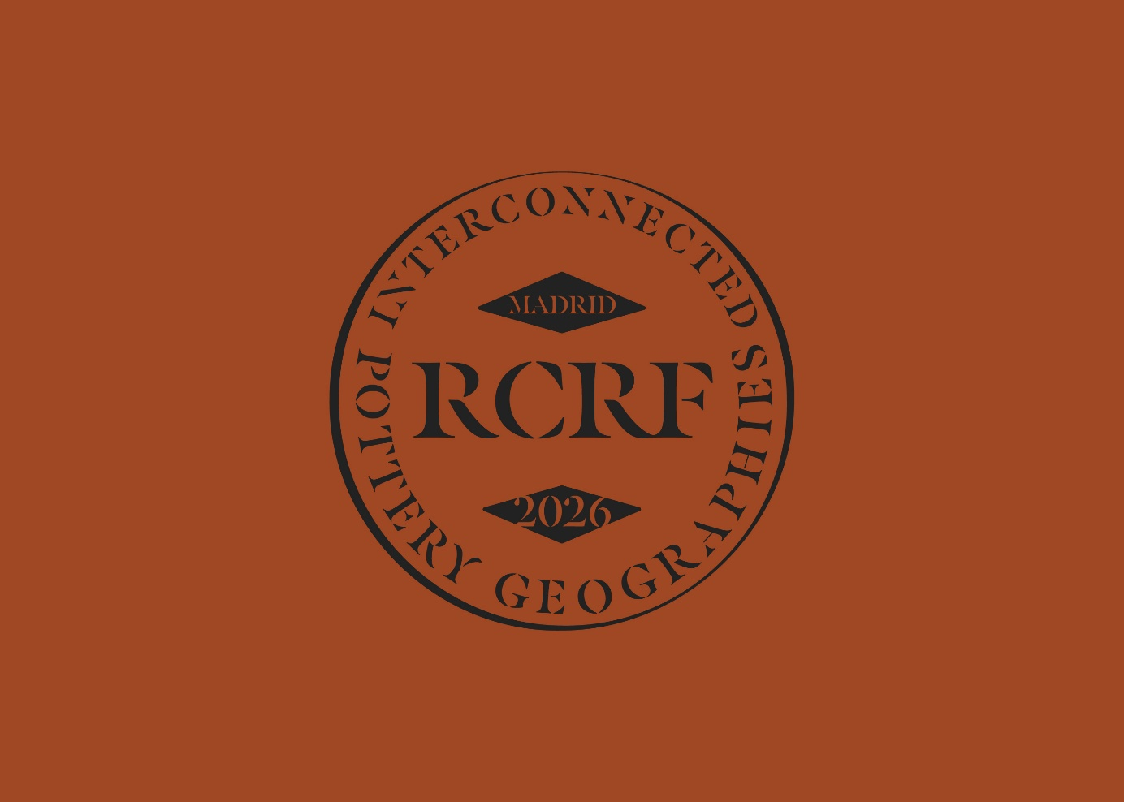

34th Congress of the Rei Cretariæ Romanæ Fautores
Madrid, 28 September – 02 October 2026

INTERCONECTED POTTERY GEOGRAPHIES.
REFLECTIONS OF CROSS-CULTURAL CONTACTS IN THE ROMAN AND LATE ANTIQUE WORLD

Registration Form (Registration deadline: 31 March 2026)

PERSONAL AND PROFESSIONAL DATA
Surname
First name
Title
Affiliation/Institution
Address and Postal Code
City and Country
Email address
Telephone number
I wish to attend the closing dinner | Yes/No (delete accordingly)
Dietary restrictions | To best organise the lunches, please indicate any dietary restrictions here, if any:

PARTICIPATION
I wish to participate with a | Presentation/Poster/I will participate without presentation or poster (delete accordingly)
Co-authors (in case of multiple authors, we kindly request that each author who will participate in the conference in person fills in a separate registration form)
Title
Abstract (max. 200 words)

POST-CONGRESS EXCURSIONS
Would you like to participate in the post-congress excursion(s) to?
Clunia (Saturday October 3rd) | Yes/No (delete accordingly)
Santa María de Melque and Toledo (Sunday October 4th) | Yes/No (delete accordingly)

GRANTS FROM THE RCRF TRUST
Would you like to apply for a grant from the RCRF Trust for financial support in case your abstract is accepted?
Yes/No (delete accordingly)

